**Assignment 2: Naïve Bayes Classifier and Optimal Bayes Error**

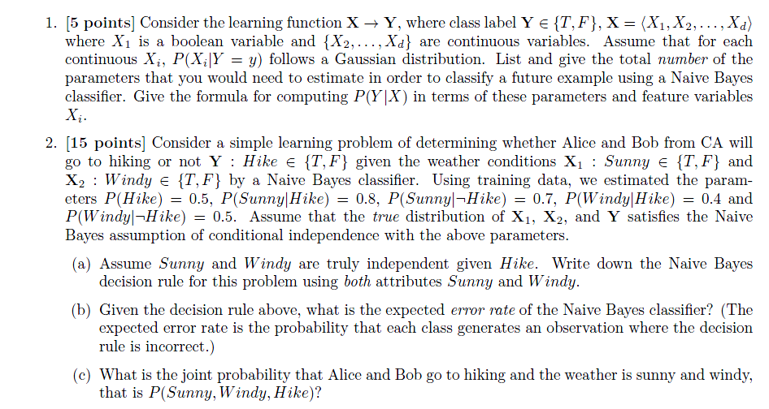

Answer for (b)

1. P(Hike) = P(~Hike) = 0.5

Conditional Probability P(Sunny | Hike) and P(Sunny | ~Hike):

|  |  |  |
| --- | --- | --- |
| **Hike** | Sunny |  |
|  | T | F |
| **T** | 0.8 | 0.2 |
| **F** | 0.7 | 0.3 |

Conditioinal Probability P(Windy | Hike) and P(Windy | ~Hike)

|  |  |  |
| --- | --- | --- |
| **Hike** | Windy |  |
|  | T | F |
| **T** | 0.4 | 0.6 |
| **F** | 0.5 | 0.5 |

Joint Probability and Loss

|  |  |  |  |  |
| --- | --- | --- | --- | --- |
| Sunny | Windy | P(Hike) | P(~Hike) | **Loss - P(error)** |
| 0 | 0 | 0.06 | 0.075 | **0.06** |
| 0 | 1 | 0.04 | 0.075 | **0.04** |
| 1 | 0 | 0.24 | 0.175 | **0.175** |
| 1 | 1 | 0.16 | 0.175 | **0.16** |